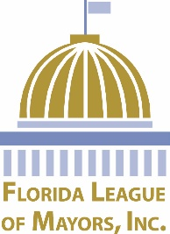
FLORIDA LEAGUE OF MAYORS PRESENTS:
FLORIDA MAYORS: Sign up today for this outstanding event!
“A UNIVERSAL TALK FOR A
UNIVERSAL MAYOR”

Wednesday, December 6, 2017 • 1:00 p.m. – 3:30 p.m.

Meet at Embassy Suites Hotel by Hilton Orlando Lake Buena Vista South
4955 Kyngs Heath Road, Kissimmee, FL 34746
Activities:
WEDNESDAY, DECEMBER 6, 2017
1:00 p.m.
*Depart from Embassy Suites Hotel FOR Comcast NBC Universal
*Participants must utilize FLM Transportation
1:30 p.m. – 3:15 p.m.
Program at Comcast NBC Universal

3:15 p.m.
Return to Embassy Suites Hotel
3:45 p.m.
FLM Board of Directors Meeting
Embassy Suites Hotel

Click here for Legislative Conference brochure.

The deadline to register for the FLM forum workshop is Friday, November 17, 2017.

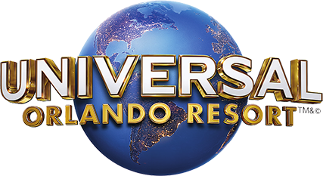

Comcast NBC Universal to host exclusive program for Florida Mayors at Universal Orlando. Mayors will have an interactive experience and hear in depth discussions centered around relevant issues impacting cities on a daily basis. This program will provide Mayors with key insights and institutional knowledge from a major corporation, which they can take back to their cities to use for future initiatives.
Session to include an overview of topics such as:
- Comcast NBC Universal company overview
- Tourist Development
- Infrastructure
- Sustainability
- Economic Development
- Learn how Universal moves projects from concepts to design

Please complete the following and return to Jill Walker by Friday, November 17, 2017, via fax at (850) 222-3806 or email: jwalker@flcities.com
(Please print or type information.)
Name/Title:

City/Town/Village:

Email:
Please check your response:
Yes No I will attend the Florida League of Mayors Roundtable on Wednesday, December 6, 2017

